Practical No:- 9
Various access control and usage of static, final and finalize ( )
final:
code->

public class MyClass {
final int age = 18;

void showAge() {
age = 55;
}

public static void main(String[] args) {

MyClass student = new MyClass();

student.showAge();
}
}

Output:->
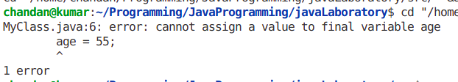

finalize:

Code->

public class finalize {
public static void main(String[] args) {
finalize str2 = new finalize();
str2 = null;

System.gc();
System.out.println("output of main method");
}

protected void finalize() {
System.out.println("output of finalize method");
}
}

Output->
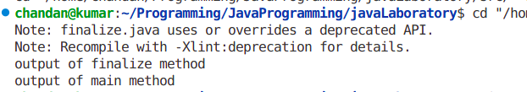

Static:

Code->

public class static1 {
// static method
static void show() {
System.out.println("Calling method without creating any object of class");
}

public static void main(String[] args) {
show();
}
}

Output:-

